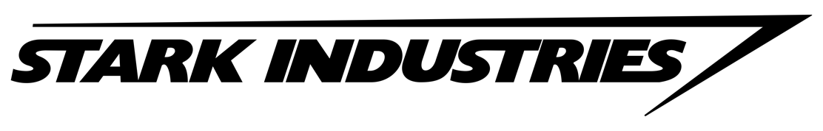

Tony Stark (aka. Iron Man) has personally asked you to advertise some of his newest, most advanced pieces of technology that expand human capability.

You may choose one of the following (or create your own):

- The Batmobile’s side-view mirrors
- Dr. Connor’s microscope
- Peter Parker’s glasses
- Captain America’s binoculars
- Black Widow’s makeup mirror
- Iron Man’s built-in eye protection
- Mystique’s contact lenses
- _________________
(must be teacher approved)

Project Goal:
Promote a piece of technology that entices people to want/need the product while using this unit’s classroom concepts, supportive evidence and a little creativity.

In This Unit, We Have Covered:
- Energy, Types of Electromagnetic Radiation
- Models of Light, Visible Light
- Image Characteristics – Location, Orientation, Size and Type
- Reflection with Concave and Convex Mirrors
- Refraction with Converging and Diverging Lenses

What is Required:
- A Form of Advertisement (poster, brochure, video)
- Product name
- Slogan
- Product features - minimum 4 features that relate to classroom concept(s)
- Where to buy, price
- Eye-catching

- Relevant to Classroom Concepts – A 150-word paragraph on how your chosen product relates to one of the following:
(A) Models of Light – Ray, Wave or Particle
(B) Characteristics of images formed
(C) Light interactions with mirrors – plane, concave and/or convex
(D) Light interactions with lenses – converging and diverging

- Support your rationale with evidence from credible sources (class notes, books, websites etc.). You must provide minimum 3 sources.

Due Date: Monday, April 16

Project Checklist – Use this checklist as a guide to ensure you are on-track to complete your project.

April 4
By the end of today’s class, I know:
- The product I have chosen to advertise: __________________________________
- The form of advertisement: ____________________________________________
Once the 2 blanks above are filled out, you must have teacher approval before proceeding.
Using the graphic organizer on page 3, I have:
- Started a brainstorm of how my product relates to the 4 outlined classroom concepts.

April 6
By the end of today’s class, I have:
- A rough draft of my advertisement
- Decided my product mainly relates to concept ( ___ ): ______________________
__________________________________________________________________

April 10
By the end of today’s class, I have started:
- A final draft of my advertisement
- A rough draft of my classroom concept paragraph

April 12
By the end of today’s class, I have:
- A rough draft of my classroom concept paragraph
- Assessed my project (advertisement, paragraph) using project rubric

April 16
I will hand in:
- A final draft of advertisement
- A good copy of my classroom concept paragraph with a self-assessed project rubric

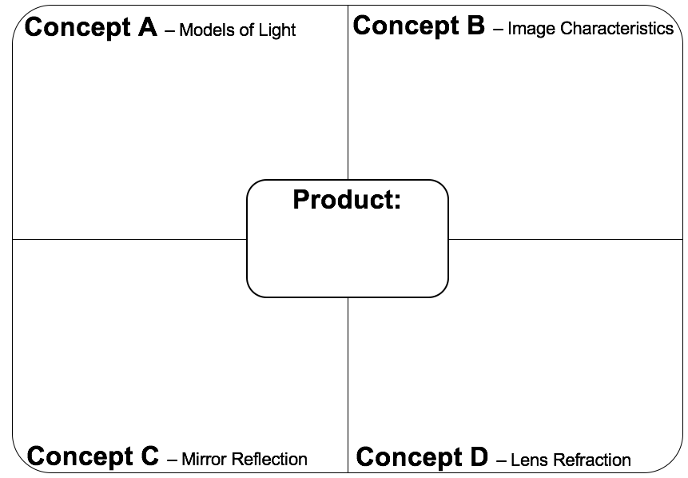
After choosing a product to advertise, use this graphic organizer to brainstorm ideas on how your product relates to one of the four concepts covered in this unit.
Science 8 – Unit Project Rubric
Product: _______________ Name: _______________
CATEGORY | EXTENDING | PROFICIENT | DEVELOPING | EMERGING
Representation  (Weight: 1.0) | The advertisement is highly well-thought out in terms of design, layout and neatness; includes all requirements | The advertisement is well-thought out in terms of design, layout and neatness; includes all requirements | The advertisement displays some thought in terms of design, layout and neatness; includes some requirements | The advertisement displays limited thought in terms of design, layout and neatness; includes few requirements
Communication  (Weight: 1.5) | Uses creative/critical thinking processes that reflects a high degree of effectiveness. | Uses creative/critical thinking that reflects a considerable degree of effectiveness. | Uses creative/critical thinking that reflects some degree of effectiveness. | Uses creative/critical thinking that reflects a limited degree of effectiveness.
Relevant to Classroom Concepts  (Weight: 1.5) | Uses a high degree of accurate, relevant information that fully supports goal of project. | Uses a considerable degree of accurate, relevant information that fully supports goal of project. | Uses some degree of accurate, relevant information that partially supports goal of project. | Uses a limited degree of accurate, relevant information that does not support goal of project.
Organization  (Weight: 1.0) | Paragraph is highly organized with logical sequencing; a few minor mechanical errors in writing. | Paragraph is clear and easy to follow; a few mechanical errors in writing. | Paragraph has minimal organization; some mechanical errors in writing. | Paragraph has no organization which may be confusing to read; contains frequent mechanical errors in writing
Sources  (Weight 1.0) | Includes 3 or more high quality sources. | Includes 2 high quality sources. | Includes 2 sources but some of are questionable quality. | Includes fewer than 2 sources.
Total: |  |  |  | /24

