6 Mark Questions

1. Describe the “fight or flight” response by completing the following information: (6 marks)

a) Division of the autonomic nervous system: _________________________________

b) Hormone responsible: ________________________________

c) Source gland of hormone: ______________________________

d) Physiological effects:

i) ___________________________________________________________

ii)___________________________________________________________

iii)___________________________________________________________

2. Explain how the neurotransmitters norepinephrine and acetylcholine interact in order to ensure that a person is prepared to respond to their environment in an appropriate way. (6 marks)

4 Mark Questions

3. Neurotransmitters have either an excitatory or inhibitory effect on the postsynaptic membrane. Describe these two effects and explain how the two effects operate to control neuron function. (4 marks)

4. Use the diagram below to answer the next question.
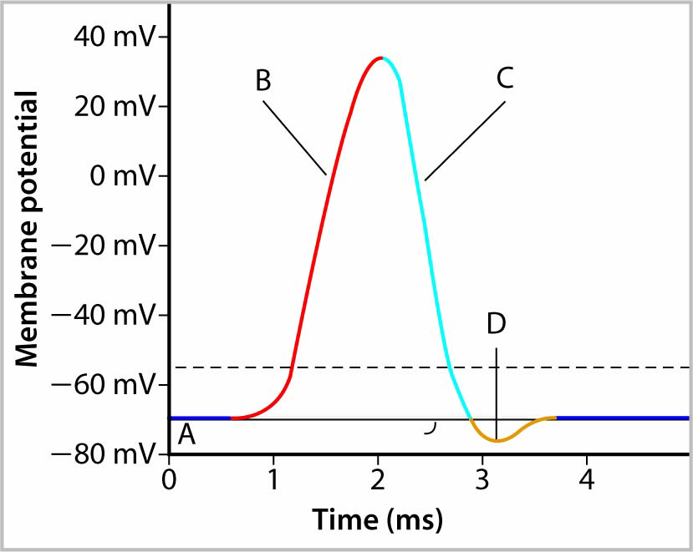

Describe the events that occur within a motor neuron at each lettered position in the diagram. (4 marks)

3 Mark Questions

5. Sodium and potassium ions maintain the resting potential of a neuron despite the fact that both are positively charged ions. How is this accomplished? (3 marks)

6. Describe three ways that the circulatory system will respond to sympathetic nerve stimulation. (3 marks)

