THE BIG ONE!!!

This is it! The moment we’ve all been waiting for! Your final science project in grade 8

For this project you will be conducting research on our impending earthquake that you have heard about for most of your lives. You will then take on the role of a journalist or newscaster and report your findings. This is due by MONDAY JUNE 18th.

Your report must include the following information:

- The tectonic plates involved, and what type of boundary they form.
- What is the geological history of these tectonic plates,
- Earthquake history
- How often do large earthquakes occur here
- When was the last major earthquake
- When do geologists estimate will be the next major earthquake etc.
- What kind of damage will happen if we experience an earthquake of magnitude 6, 7, 8, or 9+?
- What areas (cities/towns) will be most affected if we experience a major earthquake? (**HINT, consider areas like Delta and Richmond)
- Will a tsunami occur? If so what areas will most likely be affected?

You are also required to answer the following questions:

- In planning for the big one, what responsibilities do the following people/groups have:
- Individuals and their families
- Local city or town government officials
- Emergency response personnel
- Provincial and national assistance agencies.

If you take on the role of a journalist you will submit your findings in the form of a newspaper/magazine article.

If you take on the role of a newscaster you will submit your findings in the form of a video.
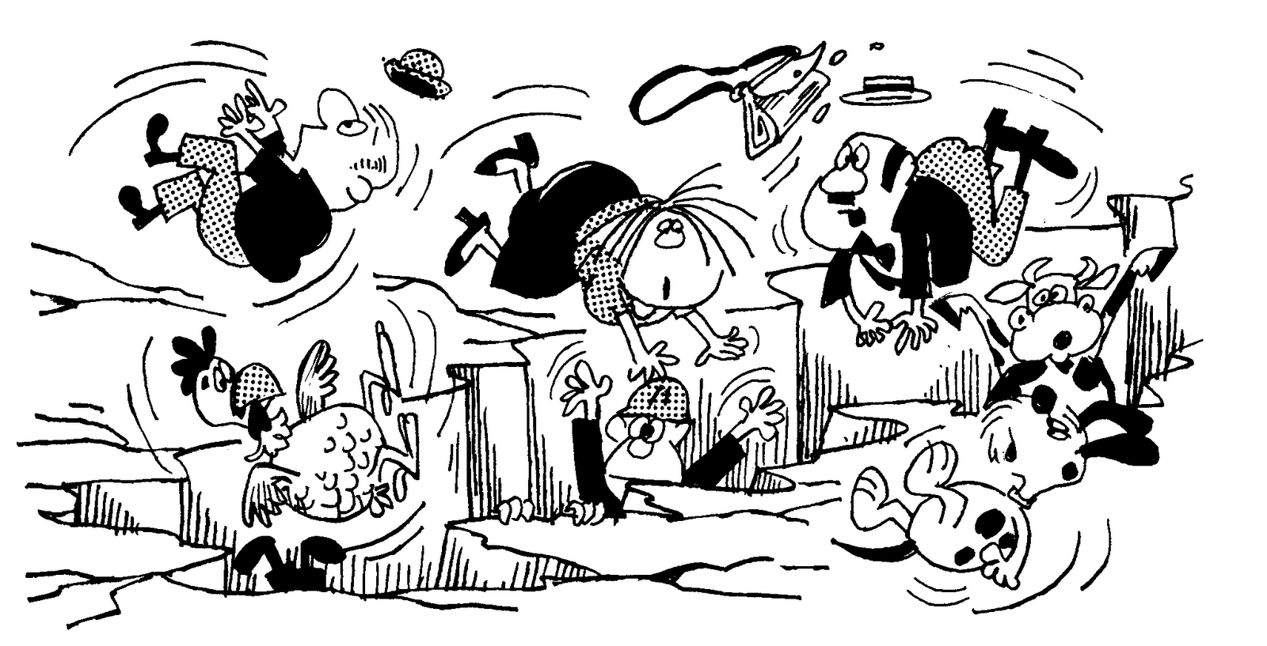
Project Checklist – Use this checklist as a guide to ensure you are on-track to complete your project.

June 8th, 2018

By the end of today’s class, I have:
- Decided if I will be a journalist or newscaster. _________________________
- Identified the tectonic plates involved _____________________________________________, and identified the type of boundary they form ____________________________.
- Researched the geological history of these tectonic plates.
  - Earthquake history
  - How often do large earthquakes occur here
  - When was the last major earthquake
  - When do geologists estimate will be the next major earthquake etc.

June 12th, 2018

By the end of today’s class, I have:
- Identified what kind of damage will happen if we experience an earthquake of magnitude 6, 7, 8, or 9+.
- Identified what areas (cities/towns) will be most affected if we experience a major earthquake.
- Determined if a tsunami will occur. If so what areas will most likely be affected?

June 14th, 2018

By the end of today’s class, I have:
- Identified what responsibilities do the following people/groups have in planning for the big one:
  - Individuals and their families
  - Local city or town government officials
  - Emergency response personnel
  - Provincial and national assistance agencies.

June 15th-17th, 2018

At home I have started to complete my report or video in preparation to submit my project on MONDAY JUNE 18th.

June 18th, 2018

Last day to work on project. MUST BE HANDED IN BY THE END OF CLASS!!!!!

Name: ______________________

CRITERIA | EMERGING | DEVELOPING | PROFICIENT | EXTENDING
Diagram/ Representation | -Poor layout and design.  -Organizes ideas in presenting results with limited effectiveness. | -Good layout and design.  -Organizes ideas and presenting results with some effectiveness. | -Great layout and design.  -Organizes ideas in presenting results with considerable effectiveness. | -Professional layout and design.  -Organizes ideas in presenting results with a high degree of effectiveness.
Analyzing | -Few or no inferences are made  -No comprehension or reflection on assignment  -Does not evaluate information for accuracy, relevance, and completeness. | Makes some inferences  -Comprehends surface level meaning  -Evaluated some aspects of the information; may not notice some flaws | -Makes inferences most of the time  -Usually comprehends deeper meanings/ connections.  -Evaluated information for accuracy, relevance and completeness | -Makes many inferences  -Comprehends deeper meanings/ connections  -Evaluated information thoroughly for accuracy, relevance and completeness.
Communication | -Uses creative/ critical thinking processes to create a final product and reflect on their learning with limited effectiveness. | -Uses creative/ critical thinking processes to create final product and to reflect on their learning with some effectiveness. | -Uses creative/ critical thinking processes to create final product and to reflect on their learning with considerable effectiveness. | - Uses creative/ critical thinking processes to create a final product and reflect on their learning with a high degree of effectiveness.
Apply/Innovate | -Opinions are either not offered or not supported by evidence  -Did not gather sufficient relevant information | -Opinions are not well developed, little supporting evidence  -Gathered some relevant information, may be partially incomplete | -Has well developed opinions and supporting evidence  -Gathered sufficient, relevant information | -Has very well developed opinions and supporting evidence  -Gathered highly appropriate relevant information
Sources | -Has provided 1 source | -Has provided 2 sources | -Has provided 3 sources | -Has provided 4 or more sources

