Chapter 5 Pre-Test (A)

Multiple Choice
Identify the choice that best completes the statement or answers the question.

____ 1. Which of the following descriptions is correct about the chemical reactions that occur in the cell?
a. | anabolism + catabolism = metabolism
b. | anabolism + metabolism = catabolism
c. | catabolism + metabolism = anabolism
d. | anabolism + catabolism = activation energy

____ 2. The products of a chemical reaction refer to the substances that
a. | initiate the reaction.
b. | undergo dehydration synthesis.
c. | are needed to start the reaction.
d. | form as a result of the reaction.

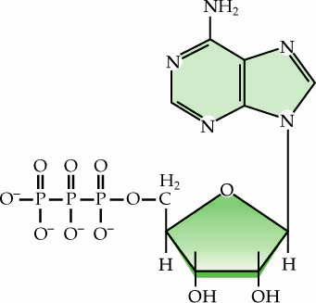

____ 3. Use the diagram above to answer the next question.
What process produces this molecule?
a. | replication
b. | photosynthesis
c. | protein synthesis
d. | cellular respiration

____ 4. Which of the following molecules is the energy currency of the cell?
a. | ATP
b. | DNA
c. | mRNA
d. | carbohydrates

____ 5. Where is the organ that produces thyroxine located in the body?
a. | in the neck
b. | in the head
c. | in the arms
d. | in the chest

____ 6. By what method does the thyroid gland take up iodine ions?
a. | osmosis
b. | diffusion
c. | active transport
d. | facilitated transport

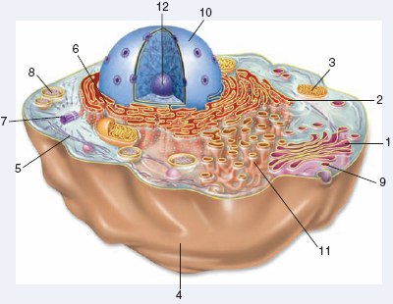

____ 7. Use the diagram above to answer the next question.
Which of the following cell structures is the location of thyroxine production?
a. | 1
b. | 2
c. | 11
d. | 12

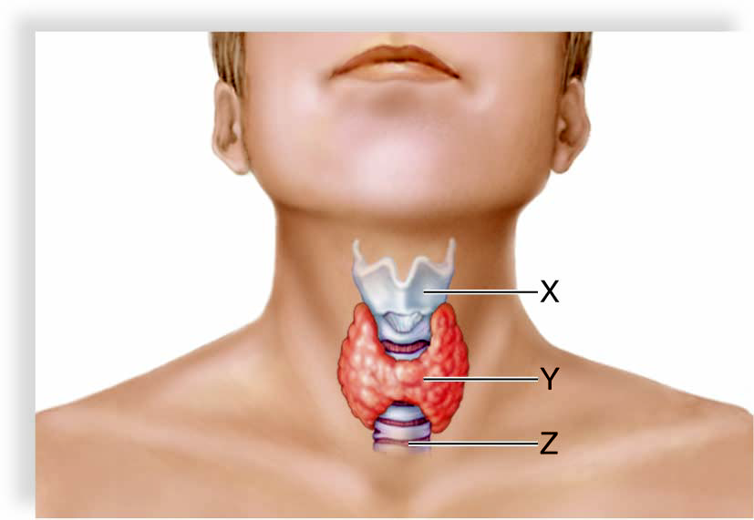

____ 8. Use the diagram above to answer the next question.
Which of the following are functions of the hormones produced in structure Y?

I | increase metabolic rate
II | increase protein synthesis
III | increase the amount of ATP used by cells

a. | I and II only
b. | I and III only
c. | II and III only
d. | I, II, and III

____ 9. Use the diagram above to answer the next question.
Which of the following statements describes a function of the hormone produced by four small glands embedded behind structure Y?
a. | causes the blood iodine levels to decrease and blood calcium levels to increase
b. | causes the blood iodine levels to decrease and blood phosphate levels to increase
c. | causes the blood phosphate levels to decrease and blood calcium levels to increase
d. | causes the blood phosphate levels to increase and blood calcium levels to decrease

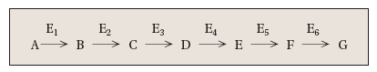

____ 10. Use the diagram above to answer the next question.
Which of the following statements describes the diagram above?
a. | B is the reactant for E₁.
b. | E₃ is the substrate for Enzyme D.
c. | C is the reactant for Enzyme 2 and the product of Enzyme 3.
d. | F is the product of Enzyme 5 and the substrate for Enzyme 6.

____ 11. Which of the following are unit molecules for enzymes?
a. | lipids
b. | glucose
c. | amino acids
d. | phospholipids

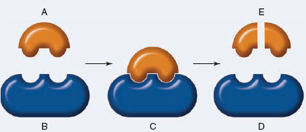

____ 12. Use the diagram above to answer the next question.
If B is ribonuclease, then what does E represent?
a. | a lipid
b. | glucose
c. | a nucleotide
d. | an amino acid

____ 13. Use the diagram above to answer the next question.
If B is amylase, then what does E represent?
a. | maltose
b. | fructose
c. | cellulose
d. | glycogen

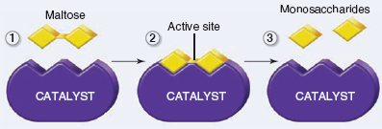

____ 14. Use the diagram above to answer the next question.
What type of reaction is shown above?
a. | synthesis
b. | hydrolysis
c. | anabolism
d. | lipid synthesis

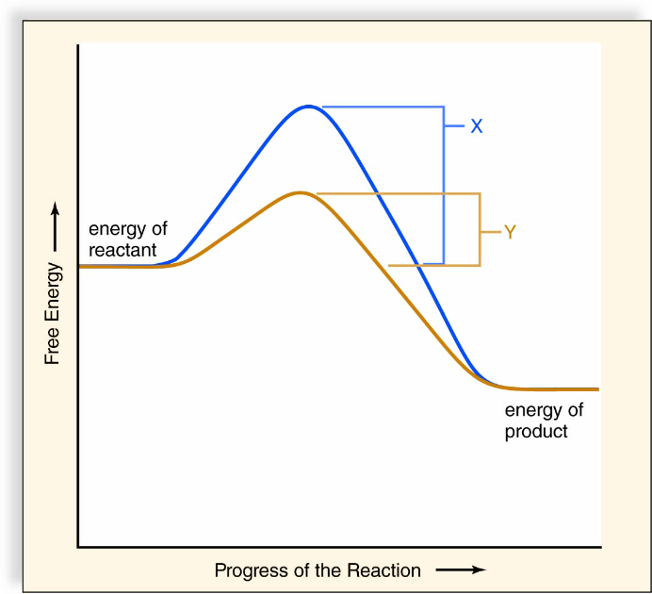

____ 15. Use the graph above to answer the next question.
What does “Y” represent in the graph?
a. | the amount of ADP produced
b. | the amount of ATP produced
c. | the amount of energy of activation required in the absence of an enzyme
d. | the amount of energy of activation required in the presence of an enzyme

____ 16. Which of the following statements explains why the active site changes its shape once the enzyme binds to a substrate?
a. | to protect the substrate
b. | to obtain energy from the substrate
c. | to hold the substrate in so that it does not fall out
d. | to achieve a better fit so that the reaction can proceed

____ 17. Which of the following factors can affect the reaction rate of enzymes?

I | cofactors
II | enzyme inhibition
III | substrate concentration

a. | I and II only
b. | I and III only
c. | II and III only
d. | I, II, and III

____ 18. Which of the following occurs due to denaturation?
a. | The R-group in the enzyme changes.
b. | The secondary structure of the enzyme changes.
c. | The amino acid sequence of the enzyme changes.
d. | The peptide bonding between the amino acids break apart.

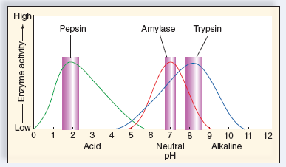

____ 19. Use the graph above to answer the next question.
At what pH does amylase bind to its substrate the best?
a. | 2
b. | 7
c. | 8
d. | 9

____ 20. Use the graph above to answer the next question.
What does the graph suggest about how pH affects enzyme activity?
a. | pH does not affect enzyme activity
b. | enzymes function best at a low pH
c. | as pH increase, so does enzyme activity
d. | each enzyme has a specific pH range in which it works best

____ 21. Which of the following pairs of enzymes carry out opposite reactions to each other?
a. | pepsin and trypsin
b. | lactase and maltase
c. | maltase and amylase
d. | kinase and phosphatase

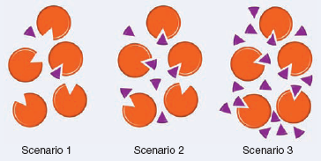

____ 22. Use the diagram above to answer the next question.
The small triangles represent substrates and the large circles represent enzymes. Which of the following explains what happens as the reaction proceeds from scenario 1 to 2 to 3?
a. | The rate of reaction stays the same.
b. | The rate of reaction decreases because there are too many substrates present.
c. | As the concentration of substrate increases, this will cause the pH to increase.
d. | As the concentration of substrate increases, the rate of reaction also increases.

____ 23. Which of the following explains how enzymes function in biochemical reactions?

I | the change in the shape of the active site is permanent
II | the active site undergoes a change in shape to fit the substrate better
III | the substrate fits into the active site of the enzyme like a lock and key

a. | I and II only
b. | I and III only
c. | II and III only
d. | I, II, and III

____ 24. The digestion of ribonucleic acid is catalyzed by a polymer made up of which of the following molecules?
a. | glucose
b. | nucleotides
c. | amino acids
d. | phospholipids

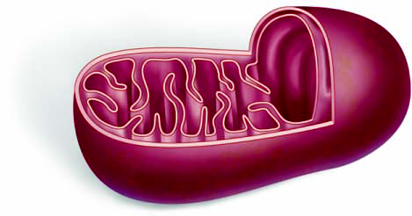

____ 25. Use the diagram above to answer the next question.
Less than half of the free energy of one of the reactants of this organelle is transformed into a energy-carrying nucleotide. The rest is
a. | lost as heat.
b. | converted into ADP.
c. | is used to make phosphate.
d. | is broken down into a nucleic acid.

Chapter 5 Pre-Test (A)
Answer Section

MULTIPLE CHOICE

1. ANS: A PTS: 1 DIF: K REF: 5
OBJ: Metabolism: Energy and Enzymes LOC: B11-1 TOP: 5.1
KEY: Energy Transformations and Metabolism

2. ANS: D PTS: 1 DIF: K REF: 5
OBJ: Metabolism: Energy and Enzymes LOC: B-S TOP: 5.1
KEY: Energy Transformations and Metabolism

3. ANS: D PTS: 1 DIF: U REF: 5
OBJ: Metabolism: Energy and Enzymes LOC: B4-18 TOP: 5.1
KEY: Energy Transformations and Metabolism

4. ANS: A PTS: 1 DIF: K REF: 5
OBJ: Metabolism: Energy and Enzymes LOC: B4-18 TOP: 5.1
KEY: Energy Transformations and Metabolism

5. ANS: A PTS: 1 DIF: U REF: 5
OBJ: Metabolism: Energy and Enzymes LOC: B11-8 TOP: 5.3
KEY: Metabolic Rate and the Thyroid and Parathyroid Glands

6. ANS: C PTS: 1 DIF: U REF: 5
OBJ: Metabolism: Energy and Enzymes LOC: B11-8 TOP: 5.3
KEY: Metabolic Rate and the Thyroid and Parathyroid Glands

7. ANS: B PTS: 1 DIF: HMP REF: 5
OBJ: Metabolism: Energy and Enzymes LOC: B11-8 TOP: 5.3
KEY: Metabolic Rate and the Thyroid and Parathyroid Glands

8. ANS: D PTS: 1 DIF: U REF: 5
OBJ: Metabolism: Energy and Enzymes LOC: B11-8 TOP: 5.3
KEY: Metabolic Rate and the Thyroid and Parathyroid Glands

9. ANS: C PTS: 1 DIF: U REF: 5
OBJ: Metabolism: Energy and Enzymes LOC: B-S TOP: 5.3
KEY: Metabolic Rate and the Thyroid and Parathyroid Glands

10. ANS: D PTS: 1 DIF: U REF: 5
OBJ: Metabolism: Energy and Enzymes LOC: B11-1 TOP: 5.2
KEY: Enzymes and Metabolic Pathways

11. ANS: C PTS: 1 DIF: U REF: 5
OBJ: Metabolism: Energy and Enzymes LOC: B11-1 TOP: 5.2
KEY: Enzymes and Metabolic Pathways

12. ANS: C PTS: 1 DIF: U REF: 5
OBJ: Metabolism: Energy and Enzymes LOC: B11-1 TOP: 5.2
KEY: Enzymes and Metabolic Pathways

13. ANS: A PTS: 1 DIF: U REF: 5
OBJ: Metabolism: Energy and Enzymes LOC: B11-1 TOP: 5.2
KEY: Enzymes and Metabolic Pathways

14. ANS: B PTS: 1 DIF: U REF: 5
OBJ: Metabolism: Energy and Enzymes LOC: B-S TOP: 5.2
KEY: Enzymes and Metabolic Pathways

15. ANS: D PTS: 1 DIF: U REF: 5
OBJ: Metabolism: Energy and Enzymes LOC: B11-2 TOP: 5.2
KEY: Enzymes and Metabolic Pathways

16. ANS: D PTS: 1 DIF: K REF: 5
OBJ: Metabolism: Energy and Enzymes LOC: B11-3 TOP: 5.2
KEY: Enzymes and Metabolic Pathways

17. ANS: D PTS: 1 DIF: K REF: 5
OBJ: Metabolism: Energy and Enzymes LOC: B11-6 TOP: 5.2
KEY: Enzymes and Metabolic Pathways

18. ANS: B PTS: 1 DIF: U REF: 5
OBJ: Metabolism: Energy and Enzymes LOC: B11-6 TOP: 5.2
KEY: Enzymes and Metabolic Pathways

19. ANS: B PTS: 1 DIF: U REF: 5
OBJ: Metabolism: Energy and Enzymes LOC: B11-6 TOP: 5.2
KEY: Enzymes and Metabolic Pathways

20. ANS: D PTS: 1 DIF: U REF: 5
OBJ: Metabolism: Energy and Enzymes LOC: B11-6 TOP: 5.2
KEY: Enzymes and Metabolic Pathways

21. ANS: D PTS: 1 DIF: U REF: 5
OBJ: Metabolism: Energy and Enzymes LOC: B11-6 TOP: 5.2
KEY: Enzymes and Metabolic Pathways

22. ANS: D PTS: 1 DIF: U REF: 5
OBJ: Metabolism: Energy and Enzymes LOC: B11-6 TOP: 5.2
KEY: Enzymes and Metabolic Pathways

23. ANS: C PTS: 1 DIF: U REF: 5
OBJ: Metabolism: Energy and Enzymes LOC: B11-3 TOP: 5.2
KEY: Enzymes and Metabolic Pathways

24. ANS: C PTS: 1 DIF: U REF: 5
OBJ: Metabolism: Energy and Enzymes LOC: B11-1 TOP: 5.2
KEY: Enzymes and Metabolic Pathways

25. ANS: A PTS: 1 DIF: HMP REF: 5
OBJ: Metabolism: Energy and Enzymes LOC: B-S TOP: 5.1
KEY: Energy Transformations and Metabolism

