Chapter 3 Pre-Test A

Multiple Choice
Identify the choice that best completes the statement or answers the question.

____ 1. Secretory vesicles are produced at the
a. | Golgi body.
b. | mitochondrion.
c. | rough endoplasmic reticulum.
d. | smooth endoplasmic reticulum.

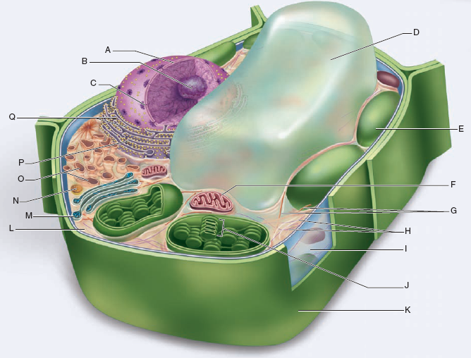

____ 2. Use the diagram above to answer the next question.
Which cell structure produces carbon dioxide?
a. | Structure D
b. | Structure E
c. | Structure F
d. | Structure O

____ 3. Which of the following describes structure A?

I | made of a phospholipid bilayer
II | has pores that mRNA can pass through
III | is continuous with the endoplasmic reticulum

a. | I and II only
b. | I and III only
c. | II and III only
d. | I, II, and III

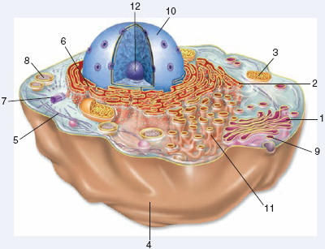

____ 4. Use the diagram above to answer the next question.
What is the function of structure 7?
a. | to synthesize lipids
b. | to produce enzymes
c. | to breakdown dead cells
d. | to produce spindle fibres

____ 5. Use the diagram above to answer the next question.
According to fluid-mosaic model, the major structural component of structure 4
a. | forms a bilayer with a fluid consistency.
b. | regulates the fluidity of the cell membrane.
c. | forms a mosaic pattern and has a hydrophobic head and hydrophilic tails.
d. | is partially embedded and positioned on the extracellular matrix side of the cell membrane.

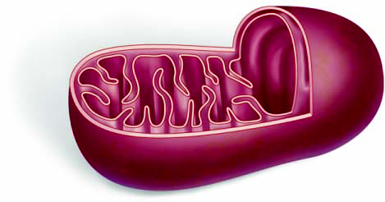

____ 6. Use the diagram above to answer the next question.
What is the chemical reaction that occurs in this organelle?
a. | C₆H₁₂O₆ + CO₂ → O₂ + H₂O + ATP
b. | O₂ + H₂O + ATP → C₆H₁₂O₆ + CO₂
c. | CO₂ + H₂O + ATP → C₆H₁₂O₆ + O₂
d. | C₆H₁₂O₆ + O₂ → CO₂ + H₂O + ATP

____ 7. Use the diagram above to answer the next question.
What is the function of this organelle?
a. | to modify proteins for secretion
b. | to produce ATP for active transport
c. | to control the cell’s metabolic activities
d. | to regulate what enters and leaves the cell

____ 8. Use the diagram above to answer the next question.
Which of the following processes requires one of the products of this organelle?
I | secretion of neurotransmitters at a synapse
II | movement of iodine ions into the thyroid gland
III | movement of sodium ions across the cell membrane in the kidney tubules

a. | I and II only
b. | I and III only
c. | II and III
d. | I, II, and III

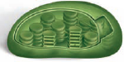

____ 9. Use the diagram above to answer the next question.
Which of the following molecules is a product of this cell structure?
a. | water
b. | oxygen
c. | carbon dioxide
d. | carbon monoxide

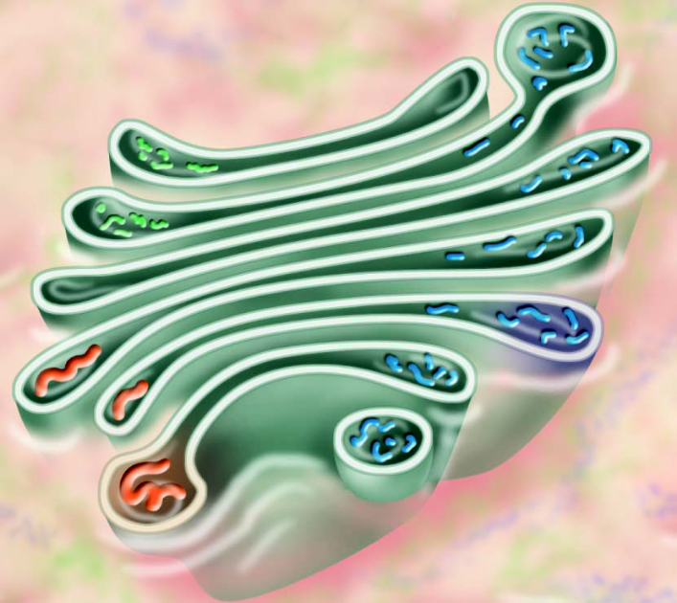

____ 10. Use the diagram above to answer the next question.
The cell structure shown is
a. | the ribosome.
b. | the Golgi body.
c. | the rough endoplasmic reticulum.
d. | the smooth endoplasmic reticulum.

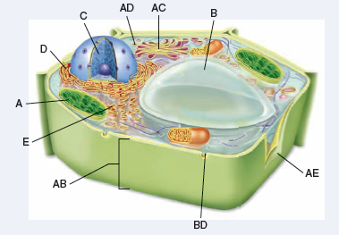

____ 11. Use the diagram above to answer the next question.
What is the function of structure AC?
a. | to produce ATP
b. | to produce DNA
c. | to digest lipids
d. | to package and sort proteins

____ 12. Which of the following descriptions refers to cilia?
a. | 9 + 0 pattern of microtubule triplets
b. | 9 + 0 pattern of microtubule doublets
c. | 9 + 2 pattern of microtubule triplets
d. | 9 + 2 pattern of microtubule doublets

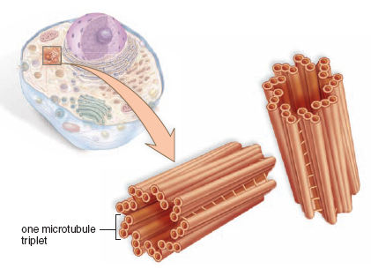

____ 13. Use the diagram above to answer the next question.
If a chemical is injected into a cell that inhibits the cell structure shown from functioning properly, which of the following events would occur?

I | microtubules would not assemble
II | cells would not be able to undergo mitosis
III | mitotic spindles would not form during cell division

a. | I and II only
b. | I and III only
c. | II and III only
d. | I, II, and III

____ 14. Which of the following statements refers to the component of the cytoskeleton that is made up of tubulin?

I | it has 13 rows of tubulin dimers
II | it is regulated by the centrosome
III | its structural composition consists of a globular protein

a. | I and II only
b. | I and III only
c. | II and III only
d. | I, II, and III

____ 15. Which of the following statements describes what happens to the surface area-to-volume ratio of a cell that has the dimensions 1 μm x 1 μm x 1 μm and tripled in size with the dimensions 3 μm x 3 μm x 3 μm?
a. | The SA:V went from 6:1 to 2:1.
b. | The SA:V went from 6:1 to 3:1.
c. | The SA:V went from 1:1 to 1:3.
d. | The SA:V went from 1:1 to 3:1.

____ 16. Which of the following will increase the rate at which glucose enters the cell?
a. | a large spherical cell
b. | a cell with a lot of folds on its surface
c. | a cell with a small surface area-to-volume ratio
d. | a cell with a large nuclear envelope and small cell membrane

____ 17. Which of the following could increase the rate at which a cell could exchange nutrients and waste?
a. | divide in half
b. | double in size
c. | decrease the amount of folds on the surface of the cell
d. | increase the amount of cytoplasm to maximize the volume

____ 18. What do facilitated and active transport have in common?
a. | They both need ATP.
b. | They both require a carrier protein.
c. | They both involve vesicle formation.
d. | They both go against the concentration gradient.

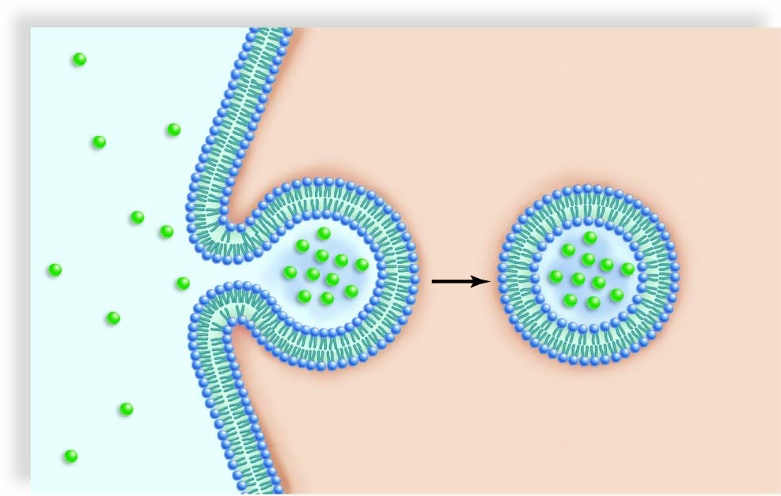

____ 19. Use the diagram above to answer the next question.
Which of the following types of molecules is taken in by the process shown?
a. | glucose
b. | glycerol
c. | sodium ions
d. | carbon dioxide

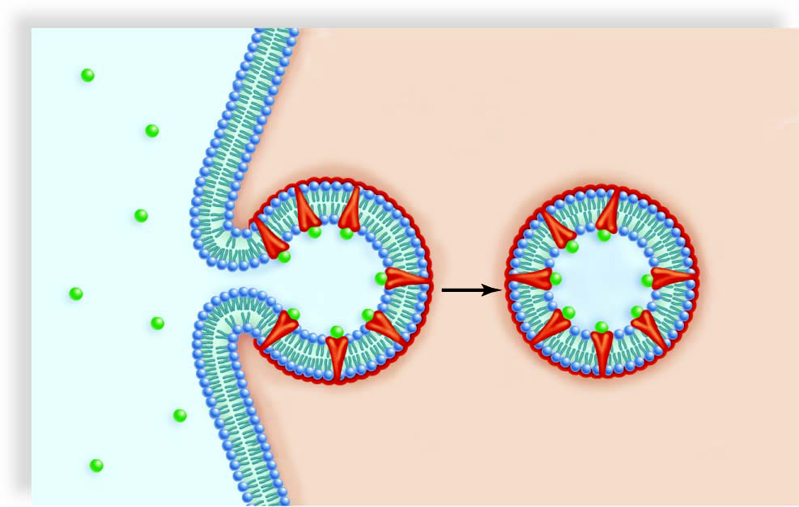

____ 20. Use the diagram above to answer the next question.
Which of the following processes is shown above?
a. | exocytosis
b. | pinocytosis
c. | phagocytosis
d. | receptor-mediated endocytosis

____ 21. By what process does oxygen from the alveoli of the lungs enter the capillaries?
a. | osmosis
b. | diffusion
c. | active transport
d. | facilitated transport

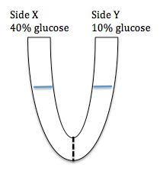

____ 22. Use the diagram above to answer the next question.
A U-tube has a membrane that is only permeable to water separating side X and Side Y. Side X is filled with a 40% glucose solution and side Y is filled with a 10% glucose solution. Which of the following statements describes what happens over time?
a. | there will be a net movement of water from side X to side Y
b. | there will be a net movement of water from side Y to side X
c. | there will be a net movement of glucose from side X to side Y
d. | there will be a net movement of glucose from side Y to side X

____ 23. Which of the following processes will occur when an animal cell is placed in a hypertonic solution?
a. | lysis
b. | crenation
c. | hemolysis
d. | plasmolysis

____ 24. Which of the following processes will occur when a plant cell is placed in a hypertonic solution?
a. | lysis
b. | crenation
c. | hemolysis
d. | plasmolysis

____ 25. Which of the following events will occur if a plant cell is placed in a hypotonic solution?
a. | turgor pressure develops
b. | water will leave the plant cell
c. | the cytoplasm will shrink
d. | there will be no net movement of water

Chapter 3 Pre-Test A
Answer Section

MULTIPLE CHOICE

1. ANS: A PTS: 1 DIF: K REF: 3
OBJ: Cell Structure and Function LOC: B1-1 TOP: 3.2
KEY: Eukaryotic Cells

2. ANS: C PTS: 1 DIF: U REF: 3
OBJ: Cell Structure and Function LOC: B1-1 TOP: 3.2
KEY: Eukaryotic Cells

3. ANS: D PTS: 1 DIF: U REF: 3
OBJ: Cell Structure and Function LOC: B1-1 TOP: 3.2
KEY: Eukaryotic Cells

4. ANS: D PTS: 1 DIF: U REF: 3
OBJ: Cell Structure and Function LOC: B1-1 TOP: 3.2
KEY: Eukaryotic Cells

5. ANS: A PTS: 1 DIF: HMP REF: 3
OBJ: Cell Structure and Function LOC: B9-1 TOP: 3.4
KEY: Plasma Membrane Structure and Function

6. ANS: D PTS: 1 DIF: HMP REF: 3
OBJ: Cell Structure and Function LOC: B1-2 TOP: 3.2
KEY: Eukaryotic Cells

7. ANS: B PTS: 1 DIF: U REF: 3
OBJ: Cell Structure and Function LOC: B1-1 TOP: 3.2
KEY: Eukaryotic Cells

8. ANS: D PTS: 1 DIF: HMP REF: 3
OBJ: Cell Structure and Function LOC: B9-8 TOP: 3.5
KEY: Permeability of Plasma Membrane

9. ANS: B PTS: 1 DIF: U REF: 3
OBJ: Cell Structure and Function LOC: B1-1 TOP: 3.2
KEY: Eukaryotic Cells

10. ANS: B PTS: 1 DIF: K REF: 3
OBJ: Cell Structure and Function LOC: B1-4 TOP: 3.2
KEY: Eukaryotic Cells

11. ANS: D PTS: 1 DIF: U REF: 3
OBJ: Cell Structure and Function LOC: B1-1 TOP: 3.2
KEY: Eukaryotic Cells

12. ANS: D PTS: 1 DIF: K REF: 3
OBJ: Cell Structure and Function LOC: B1-1 TOP: 3.3
KEY: Cytoskeleton

13. ANS: D PTS: 1 DIF: HMP REF: 3
OBJ: Cell Structure and Function LOC: B1-1 TOP: 3.3
KEY: Cytoskeleton

14. ANS: D PTS: 1 DIF: U REF: 3
OBJ: Cell Structure and Function LOC: B1-1 TOP: 3.3
KEY: Cytoskeleton

15. ANS: A PTS: 1 DIF: U REF: 3
OBJ: Cell Structure and Function LOC: B10-1 TOP: 3.1
KEY: Cellular Level of Organization

16. ANS: B PTS: 1 DIF: U REF: 3
OBJ: Cell Structure and Function LOC: B10-2 TOP: 3.1
KEY: Cellular Level of Organization

17. ANS: A PTS: 1 DIF: U REF: 3
OBJ: Cell Structure and Function LOC: B10-2 TOP: 3.1
KEY: Cellular Level of Organization

18. ANS: B PTS: 1 DIF: U REF: 3
OBJ: Cell Structure and Function LOC: B9-8 TOP: 3.5
KEY: Permeability of Plasma Membrane

19. ANS: A PTS: 1 DIF: U REF: 3
OBJ: Cell Structure and Function LOC: B9-7 TOP: 3.5
KEY: Permeability of Plasma Membrane

20. ANS: D PTS: 1 DIF: U REF: 3
OBJ: Cell Structure and Function LOC: B9-7 TOP: 3.5
KEY: Permeability of Plasma Membrane

21. ANS: B PTS: 1 DIF: K REF: 3
OBJ: Cell Structure and Function LOC: B9-4 TOP: 3.5
KEY: Permeability of Plasma Membrane

22. ANS: B PTS: 1 DIF: U REF: 3
OBJ: Cell Structure and Function LOC: B9-4 TOP: 3.5
KEY: Permeability of Plasma Membrane

23. ANS: B PTS: 1 DIF: U REF: 3
OBJ: Cell Structure and Function LOC: B9-6 TOP: 3.5
KEY: Permeability of Plasma Membrane

24. ANS: D PTS: 1 DIF: U REF: 3
OBJ: Cell Structure and Function LOC: B9-4 TOP: 3.5
KEY: Permeability of Plasma Membrane

25. ANS: A PTS: 1 DIF: U REF: 3
OBJ: Cell Structure and Function LOC: B9-4 TOP: 3.5
KEY: Permeability of Plasma Membrane

