Chapter 14 Pre-Test A

Multiple Choice
Identify the choice that best completes the statement or answers the question.

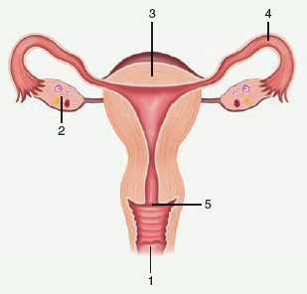

____ 1. Use the diagram above to answer the next question.
At which location does the proliferation of endometrium occur?
a. | 2
b. | 3
c. | 4
d. | 5

____ 2. Use the diagram above to answer the next question.
At which location does the follicular phase occur?
a. | 2
b. | 3
c. | 4
d. | 5

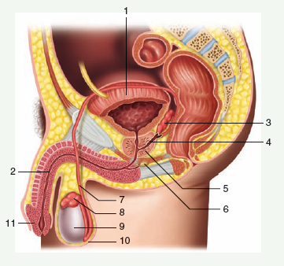

____ 3. Use the diagram above to answer the next question.
Which structure is the seminal vesicle?
a. | 3
b. | 5
c. | 6
d. | 8

____ 4. Use the diagram above to answer the next question.
Which structure is the Cowper’s gland?
a. | 3
b. | 5
c. | 6
d. | 8

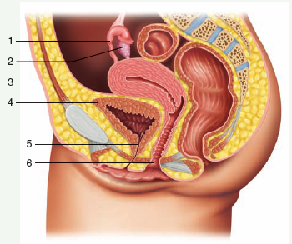

____ 5. Use the diagram above to answer the next question.
Which of the following descriptions applies to location 6?
a. | site of egg development
b. | site of embryonic development
c. | receives penis during intercourse
d. | secretes follicle stimulating hormone

____ 6. Which of the following rows has the organs of the male reproductive system correctly matched with its function?
 | Organ | Function
A. | testes | secrete testosterone
B. | urethra | nourishes sperm
C. | epididymis | contributes alkaline fluid to semen
D. | seminal vesicle | carries semen into female reproductive tract

a. | A
b. | B
c. | C
d. | D

____ 7. Which of the following changes occurs at the time of menstruation?
a. | a rise in the level of LH
b. | a drop in the level of testosterone
c. | a rise in the level of estrogen and progesterone
d. | a drop in the level of estrogen and progesterone

____ 8. The level of sperm production remains relatively constant all the time. The reason for this is a feedback loop between
a. | LH and FSH.
b. | LH and inhibin.
c. | FSH and inhibin.
d. | inhibin and testosterone.

____ 9. Which of the following hormones is only released after implantation has occurred?
a. | estrogen
b. | progesterone
c. | human chorionic gonadotropin
d. | gonadotropin-releasing hormone

____ 10. Which hormone is matched with its function?
a. | HCG = causes uterine contractions
b. | oxytocin = stimulates milk production
c. | progesterone = stimulates release of LH
d. | estrogen = stimulates production of HCG

____ 11. When the concentration of LH in a man’s blood increases, its production is inhibited by rising levels of
a. | FSH.
b. | GnRH.
c. | testosterone.
d. | human chorionic gonadotropin.

____ 12. The process of spermatogenesis occurs in the
a. | scrotum.
b. | vas deferens.
c. | interstitial cells.
d. | seminiferous tubules.

____ 13. Ovulation occurs immediately after a sharp rise in the levels of
a. | estrogen.
b. | progesterone.
c. | luteinizing hormone.
d. | human chorionic gonadotropin.

____ 14. Which of the following describes the pathway that sperm follow prior to fertilization?
a. | vagina → cervix → oviduct → uterus
b. | cervix → uterus → vagina → oviduct
c. | cervix → oviduct → vagina → uterus
d. | vagina → cervix → uterus → oviduct

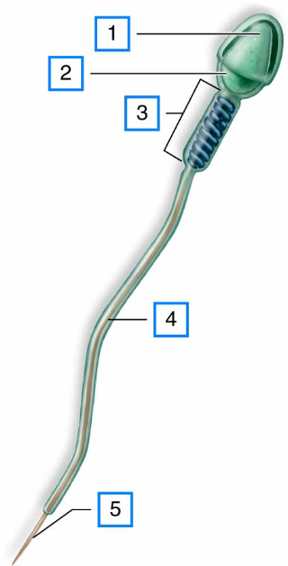

____ 15. Use the diagram above to answer the next question.
Which structure contains genetic information?
a. | 2
b. | 3
c. | 4
d. | 5

____ 16. Which phase of the uterine cycle occurs between day 5 and day 13?
a. | luteal phase
b. | secretory phase
c. | menstrual phase
d. | proliferative phase

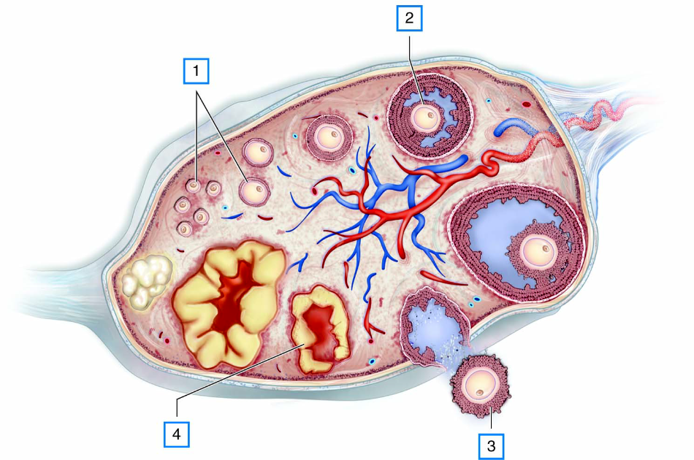

____ 17. Use the diagram above to answer the next question.
Which of the following events is responsible for the process occurring at location 3?
a. | decreasing in levels of estrogen
b. | increasing levels of progesterone
c. | increasing levels of luteinizing hormone
d. | increasing levels of human chorionic gonadotropin

____ 18. Use the diagram above to answer the next question.
Which of the following events will occur as a result of secretions from location 4?
a. | Menstruation will occur.
b. | Endometrium will thicken.
c. | Levels of HCG will increase.
d. | Uterine lining will produce mucus.

____ 19. Use the diagram above to answer the next question.
Which of the following phases of the ovarian or uterine cycle will occur as a result of secretions from location 4?
a. | menstruation
b. | follicular phase
c. | secretory phase
d. | proliferative phase

____ 20. Which of the following conditions will likely occur if the prostate is not functioning properly?
a. | Sperm would not have the necessary nutrients.
b. | Sperm would not have a fluid in which to swim.
c. | Sperm would not survive conditions in the vagina.
d. | Sperm would be unable to penetrate the outer layer of the egg.

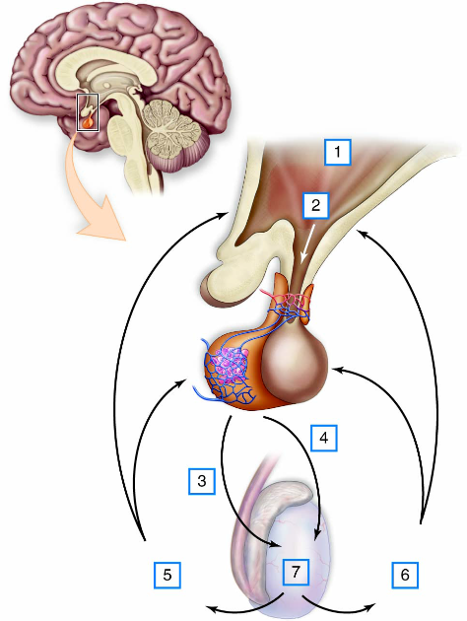

____ 21. Use the diagram above to answer the next question.
Which of the following events will happen because of secretions at location 1?
a. | Pubic hair will grow.
b. | FSH levels will decrease.
c. | Interstitial cells will produce sperm.
d. | Seminiferous tubules will produce testosterone.

____ 22. Use the diagram above to answer the next question.
What impact will hormone 3 have on interstitial cells?
a. | It will promote spermatogenesis.
b. | It will cause levels of FSH to increase.
c. | It will cause levels of GnRH to increase.
d. | It will promote synthesis of testosterone.

____ 23. Which of the following processes occurs because of positive feedback from the hypothalamus during the follicular phase?
a. | ovulation
b. | implantation
c. | menstruation
d. | proliferation of endometrium

____ 24. Which of the following events will occur if implantation does not occur?
a. | Levels of HCG will rise.
b. | Levels of estrogen will rise.
c. | The corpus luteum will start to degenerate.
d. | Levels of follicle stimulating hormone will decrease.

____ 25. Which of the following structures has a function that is least like that of the other three?
a. | prostate gland
b. | Cowper’s gland
c. | seminal vesicles
d. | seminiferous tubules

Chapter 14 Pre-Test A
Answer Section

MULTIPLE CHOICE

1. ANS: B PTS: 1 DIF: U REF: 14
OBJ: Reproductive System LOC: C15-4 TOP: 14.3
KEY: Ovarian Uterine Cycles

2. ANS: A PTS: 1 DIF: U REF: 14
OBJ: Reproductive System LOC: C15-3 TOP: 14.3
KEY: Ovarian Uterine Cycles

3. ANS: A PTS: 1 DIF: K REF: 14
OBJ: Reproductive System LOC: C14-1 TOP: 14.1
KEY: Male Reproductive System

4. ANS: C PTS: 1 DIF: K REF: 14
OBJ: Reproductive System LOC: C14-1 TOP: 14.1
KEY: Male Reproductive System

5. ANS: C PTS: 1 DIF: U REF: 14
OBJ: Reproductive System LOC: C15-1 TOP: 14.2
KEY: Female Reproductive System

6. ANS: A PTS: 1 DIF: K REF: 14
OBJ: Reproductive System LOC: C14-1 TOP: 14.1
KEY: Male Reproductive System

7. ANS: D PTS: 1 DIF: U REF: 14
OBJ: Reproductive System LOC: C15-5 TOP: 14.3
KEY: Ovarian Uterine Cycles

8. ANS: C PTS: 1 DIF: U REF: 14
OBJ: Reproductive System LOC: C14-6 TOP: 14.1
KEY: Male Reproductive System

9. ANS: C PTS: 1 DIF: U REF: 14
OBJ: Reproductive System LOC: C15-6 TOP: 14.3
KEY: Ovarian Uterine Cycles

10. ANS: B PTS: 1 DIF: K REF: 14
OBJ: Reproductive System LOC: C15-7 TOP: 14.3
KEY: Ovarian Uterine Cycles

11. ANS: C PTS: 1 DIF: K REF: 14
OBJ: Reproductive System LOC: C14-6 TOP: 14.1
KEY: Male Reproductive System

12. ANS: D PTS: 1 DIF: K REF: 14
OBJ: Reproductive System LOC: C14-2 TOP: 14.1
KEY: Male Reproductive System

13. ANS: C PTS: 1 DIF: K REF: 14
OBJ: Reproductive System LOC: C15-5 TOP: 14.3
KEY: Female Reproductive System

14. ANS: D PTS: 1 DIF: U REF: 14
OBJ: Reproductive System LOC: C15-1 TOP: 14.2
KEY: Female Reproductive System

15. ANS: A PTS: 1 DIF: U REF: 14
OBJ: Reproductive System LOC: C14-4 TOP: 14.1
KEY: Male Reproductive System

16. ANS: D PTS: 1 DIF: U REF: 14
OBJ: Reproductive System LOC: C15-4 TOP: 14.3
KEY: Ovarian Uterine Cycles

17. ANS: C PTS: 1 DIF: U REF: 14
OBJ: Reproductive System LOC: C15-5 TOP: 14.3
KEY: Ovarian Uterine Cycles

18. ANS: D PTS: 1 DIF: HMP REF: 14
OBJ: Reproductive System LOC: C15-5 TOP: 14.3
KEY: Ovarian Uterine Cycles

19. ANS: C PTS: 1 DIF: U REF: 14
OBJ: Reproductive System LOC: C15-5 TOP: 14.3
KEY: Ovarian Uterine Cycles

20. ANS: C PTS: 1 DIF: U REF: 14
OBJ: Reproductive System LOC: C14-3 TOP: 14.1
KEY: Male Reproductive System

21. ANS: A PTS: 1 DIF: HMP REF: 14
OBJ: Reproductive System LOC: C14-6 TOP: 14.1
KEY: Male Reproductive System

22. ANS: D PTS: 1 DIF: U REF: 14
OBJ: Reproductive System LOC: C14-6 TOP: 14.1
KEY: Male Reproductive System

23. ANS: A PTS: 1 DIF: HMP REF: 14
OBJ: Reproductive System LOC: C15-5 TOP: 14.3
KEY: Ovarian Uterine Cycles

24. ANS: C PTS: 1 DIF: U REF: 14
OBJ: Reproductive System LOC: C15-6 TOP: 14.3
KEY: Ovarian Uterine Cycles

25. ANS: D PTS: 1 DIF: U REF: 14
OBJ: Reproductive System LOC: C14-3 TOP: 14.1
KEY: Male Reproductive System

