Chapter 13 Pre-Test A

Multiple Choice
Identify the choice that best completes the statement or answers the question.

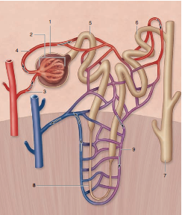

____ 1. Use the diagram above to answer the next question.
In the diagram above, the afferent arteriole is numbered
a. | 3.
b. | 4.
c. | 6.
d. | 9.

____ 2. Use the diagram above to answer the next question.
In the diagram above, the proximal convoluted tubule is numbered
a. | 5.
b. | 6.
c. | 7.
d. | 8.

____ 3. Use the diagram above to answer the next question.
In the diagram above, the site where glucose is reabsorbed is at location
a. | 5.
b. | 6.
c. | 7.
d. | 8.

____ 4. Use the diagram above to answer the following question.
Which of the following present in structure 5, are responsible for increasing reabsorption?

I | lipids
II | mitochondria
III | transport proteins

a. | I and II only
b. | I and III only
c. | II and III only
d. | I, II and III

____ 5. Use the diagram above to answer the next question.
Which of the following substances is excreted at location 6?
a. | glucose
b. | penicillin
c. | red blood cells
d. | white blood cells

____ 6. Which of the following rows correctly matches the part of the nephron with its excretory function?
Row | Structures of the Nephron | Function
A. | glomerulus | passive transport of solutes
B. | collecting duct | reception of glomerular filtrate
C. | descending loop of Henle | active reabsorption of sodium ions
D. | proximal convoluted tubule | active reabsorption of glucose molecules

a. | A
b. | B
c. | C
d. | D

____ 7. Which of the following structures has both a urinary and reproductive function in males?
a. | ureter
b. | urethra
c. | nephron
d. | urinary bladder

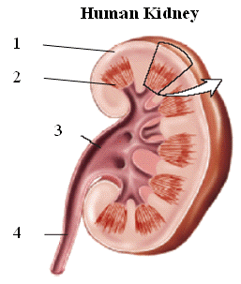

____ 8. Use the diagram above to answer the next question.
Which component is responsible for carrying urine to the urinary bladder?
a. | 1
b. | 2
c. | 3
d. | 4

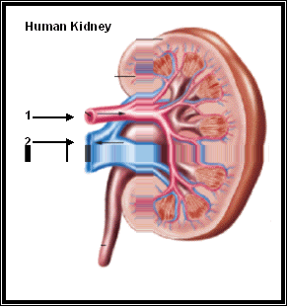

____ 9. Use the diagram above to answer the next question
Which comparison of the blood in vessel 1 and 2 is correct?
 | Vessel 1 | Vessel 2
A | lower urea and glucose | higher urea and glucose
B | higher urea and glucose | lower urea and glucose
C | lower urea/ higher glucose | higher urea/lower glucose
D | higher urea/lower glucose | lower urea/higher glucose

a. | A
b. | B
c. | C
d. | D

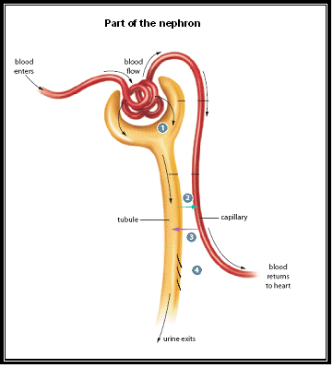

____ 10. Use the diagram above to answer the next question.
The numbers 1, 2, 3, and 4 represent the sequence of four processes that are crucial during urine formation. At which step is a plasma-like filtrate of blood created?
a. | 1
b. | 2
c. | 3
d. | 4

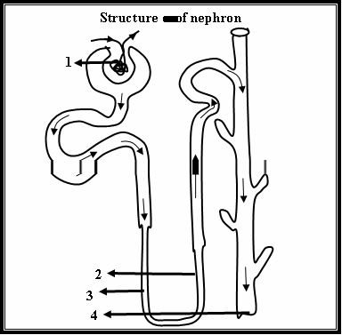

____ 11. Use the diagram above to answer the next question.
At which location would the fluids most resemble the composition of urine?
a. | 1
b. | 2
c. | 3
d. | 4

____ 12. Use the diagram above to answer the next question.
Which one of the following substances opens aquaporin channels in structure number 4 when solutes in blood are too high?
a. | aldosterone
b. | sodium ions
c. | hydrogen ions
d. | antidiuretic hormone

____ 13. Which of the following substances will not usually pass through the glomerulus?
a. | ions
b. | water
c. | hemoglobin
d. | amino acids

____ 14. Which component of the filtrate, when reabsorbed, contributes most to the decrease in volume as urine forms?
a. | water
b. | glucose
c. | amino acids
d. | sodium ions

____ 15. At which location in the nephron do substances like creatinine, penicillin and other drugs enter the filtrate?
a. | loop of Henle
b. | collecting tubules
c. | distal convoluted tubules
d. | proximal convoluted tubules

____ 16. Which region of the nephron would be most impacted by hypotension?
a. | loop of Henle
b. | collecting duct
c. | Bowman’s capsule
d. | proximal convoluted tubule

____ 17. What is the function of antidiuretic hormone?
a. | to change the blood pH
b. | to stimulate urine production
c. | to transport blood to the kidneys
d. | to control the concentration of the urine

____ 18. In which procedure is blood pumped from the renal artery to an artificial membrane in an external device and then returned to the body by way of the renal vein?
a. | urinalysis
b. | hemodialysis
c. | kidney transplant
d. | removal of kidney stones

____ 19. Antidiuretic hormone (ADH) is produced in the
a. | kidneys.
b. | hypothalamus.
c. | adrenal medulla.
d. | posterior pituitary.

____ 20. Which of these substances is not normally found in urine?
a. | urea
b. | glucose
c. | uric acid
d. | creatinine

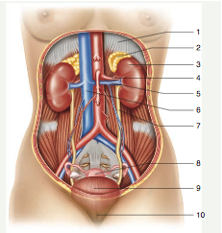

____ 21. Use the diagram above to answer the next question.
The structures that transport urine are numbered
a. | 2 and 3.
b. | 3 and 9.
c. | 4 and 5.
d. | 7 and 10.

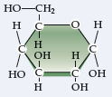

____ 22. Use the diagram above to answer the next question.
If the substance above is detected in urine, which of the following processes occurred?
a. | Urine formed normally.
b. | Selective reabsorption was insufficient.
c. | Tubular excretion was greater than normal.
d. | The tonicity of the renal medulla was lower than normal.

____ 23. Which of the following blood pH would cause higher levels of bicarbonate to be excreted?
a. | 6.6
b. | 7.0
c. | 7.4
d. | 8.0

____ 24. Under which of the following conditions would the largest quantity of be excreted?
a. | low blood pressure and low blood pH
b. | low blood pressure and high blood pH
c. | high blood pressure and low blood pH
d. | high blood pressure and high blood pH

____ 25. Under which of the following conditions would the largest quantity of be excreted?
a. | low blood pressure and low blood pH
b. | low blood pressure and high blood pH
c. | high blood pressure and low blood pH
d. | high blood pressure and high blood pH

Chapter 13 Pre-Test A
Answer Section

MULTIPLE CHOICE

1. ANS: A PTS: 1 DIF: K REF: 13
OBJ: Urinary System LOC: C13-2 TOP: 13.2
KEY: Anatomy Kidney Excretion

2. ANS: A PTS: 1 DIF: K REF: 13
OBJ: Urinary System LOC: C13-2 TOP: 13.2
KEY: Anatomy Kidney Excretion

3. ANS: A PTS: 1 DIF: U REF: 13
OBJ: Urinary System LOC: C13-2 TOP: 13.2
KEY: Anatomy Kidney Excretion

4. ANS: C PTS: 1 DIF: U REF: 13
OBJ: Urinary System LOC: C13-2 TOP: 13.2
KEY: Anatomy Kidney Excretion

5. ANS: B PTS: 1 DIF: U REF: 13
OBJ: Urinary System LOC: C13-3 TOP: 13.2
KEY: Anatomy Kidney Excretion

6. ANS: D PTS: 1 DIF: U REF: 13
OBJ: Urinary System LOC: C13-3 TOP: 13.2
KEY: Anatomy Kidney Excretion

7. ANS: B PTS: 1 DIF: U REF: 13
OBJ: Urinary System LOC: C13-1 TOP: 13.1
KEY: Urinary System

8. ANS: D PTS: 1 DIF: U REF: 13
OBJ: Urinary System LOC: C13-3 TOP: 13.2
KEY: Anatomy Kidney Excretion

9. ANS: B PTS: 1 DIF: U REF: 13
OBJ: Urinary System LOC: C13-5 TOP: 13.2
KEY: Anatomy Kidney Excretion

10. ANS: A PTS: 1 DIF: U REF: 13
OBJ: Urinary System LOC: C13-3 TOP: 13.2
KEY: Anatomy Kidney Excretion

11. ANS: D PTS: 1 DIF: U REF: 13
OBJ: Urinary System LOC: C13-3 TOP: 13.2
KEY: Anatomy Kidney Excretion

12. ANS: D PTS: 1 DIF: U REF: 13
OBJ: Urinary System LOC: C13-7 TOP: 13.3
KEY: Kidney Function Regulation

13. ANS: C PTS: 1 DIF: U REF: 13
OBJ: Urinary System LOC: C13-3 TOP: 13.2
KEY: Anatomy Kidney Excretion

14. ANS: A PTS: 1 DIF: K REF: 13
OBJ: Urinary System LOC: C13-3 TOP: 13.2
KEY: Anatomy Kidney Excretion

15. ANS: C PTS: 1 DIF: K REF: 13
OBJ: Urinary System LOC: C13-3 TOP: 13.2
KEY: Anatomy Kidney Excretion

16. ANS: C PTS: 1 DIF: U REF: 13
OBJ: Urinary System LOC: C13-3 TOP: 13.2
KEY: Anatomy Kidney Excretion

17. ANS: D PTS: 1 DIF: K REF: 13
OBJ: Urinary System LOC: C13-7 TOP: 13.3
KEY: Kidney Function Regulation

18. ANS: B PTS: 1 DIF: K REF: 13
OBJ: Urinary System LOC: C-S TOP: 13.4
KEY: Urinary System Disorders

19. ANS: B PTS: 1 DIF: K REF: 13
OBJ: Urinary System LOC: C13-6 TOP: 13.3
KEY: Kidney Function Regulation

20. ANS: B PTS: 1 DIF: K REF: 13
OBJ: Urinary System LOC: C13-3 TOP: 13.2
KEY: Anatomy Kidney Excretion

21. ANS: D PTS: 1 DIF: U REF: 13
OBJ: Urinary System LOC: C13-1 TOP: 13.1
KEY: Urinary System

22. ANS: B PTS: 1 DIF: HMP REF: 13
OBJ: Urinary System LOC: C13-3 TOP: 13.2
KEY: Anatomy Kidney Excretion

23. ANS: D PTS: 1 DIF: U REF: 13
OBJ: Urinary System LOC: C13-4 TOP: 13.3
KEY: Kidney Function Regulation

24. ANS: D PTS: 1 DIF: U REF: 13
OBJ: Urinary System LOC: C13-4 TOP: 13.3
KEY: Kidney Function Regulation

25. ANS: C PTS: 1 DIF: U REF: 13
OBJ: Urinary System LOC: C13-4 TOP: 13.3
KEY: Kidney Function Regulation

