Chapter 12 Pre-Test A

Multiple Choice
Identify the choice that best completes the statement or answers the question.

____ 1. Which part of a neuron receives an impulse from the previous neuron?
a. | axon
b. | dendrite
c. | cell body
d. | axoplasm

____ 2. Which of the following is the fatty insulating layer that surrounds white matter but is absent in grey matter?
a. | myelin
b. | synapse
c. | axoplasm
d. | axomembrane

____ 3. The neurotransmitter released by the sympathetic neurons is
a. | dopamine.
b. | endorphin.
c. | acetylcholine.
d. | norepinephrine.

____ 4. The spaces between the Schwann cells of a neuron are known as
a. | axons.
b. | synapses.
c. | dendrites.
d. | nodes of Ranvier.

____ 5. Which of the following division of the nervous system is related to the fight-or-flight response?
a. | central nervous system
b. | somatic nervous system
c. | sympathetic nervous system
d. | parasympathetic nervous system

____ 6. What would be the resting membrane potential of a neuron expressed in millivolts?
a. | –70 mV
b. | –35 mV
c. | +35 mV
d. | +70 mV

____ 7. The cell membrane of a neuron cannot be stimulated to undergo an action potential
a. | if the threshold potential has been exceeded.
b. | after a resting potential has been established.
c. | during the refractory period when repolarization is occurring.
d. | during the refractory period when depolarization is occurring.

____ 8. What role does calcium ion play in the transmission of a nerve impulse from one neuron to the next?
a. | it causes the exocytosis of neurotransmitters
b. | it transmits the impulse across the synaptic cleft
c. | it combines with receptors in the post-synaptic membrane
d. | it breaks down neurotransmitter remaining in the synaptic cleft

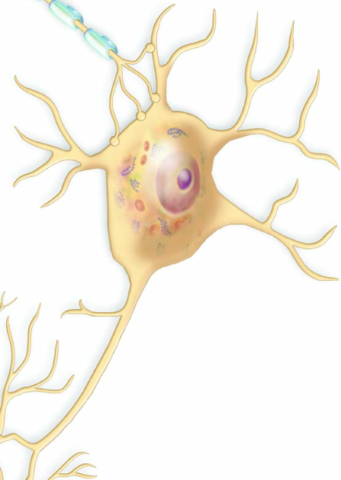

____ 9. Use the diagram above to answer the next question.
What role does this cell perform?
a. | conducts nerve impulses away from glands
b. | conducts nerve impulses toward an effector
c. | conducts nerve impulses between two neurons
d. | conducts nerve impulses away from a sensory receptor in the skin

____ 10. Use the diagram above to answer the next question.
If an action potential is generated in the dendrite of this cell, which of these actions will occur next?
a. | stimulation of a motor neuron
b. | depolarization in the axon of an interneuron
c. | depolarization in the axon of a sensory neuron
d. | release of neurotransmitter from an axon terminal

____ 11. Use the diagram above to answer the next question.
When an action potential reaches the end of this cell, which of the following events will occur?
a. | an effector will be stimulated and the muscle will respond
b. | neurotransmitter will be released and will bind to receptors in an interneuron
c. | neurotransmitter will be released and will bind to receptors in a motor neuron
d. | neurotransmitter will be released and will bind to receptors in a sensory neuron

____ 12. How is the structure of a sensory neuron related to its function?
a. | A long axon can reach from a receptor to the spinal cord.
b. | A long dendrite can reach from a receptor to the spinal cord.
c. | Large proteins ensure the axoplasm remains negatively charged at all times.
d. | Receptors in the post-synaptic membrane can bind with specific neurotransmitters.

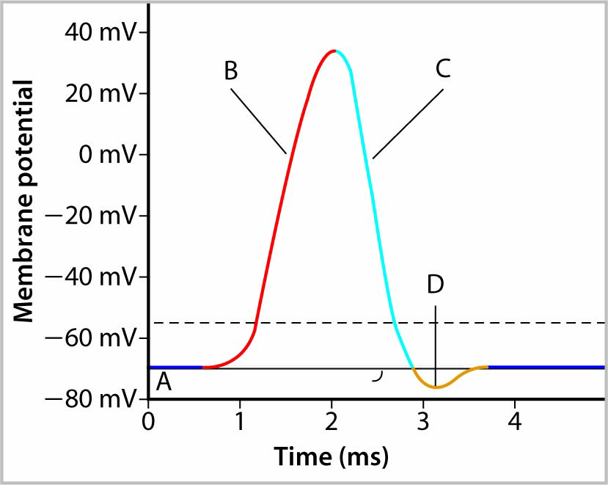

____ 13. Use the graph above to answer the next question.
During which indicated period is depolarization occurring?
a. | A
b. | B
c. | C
d. | D

____ 14. Use the graph above to answer the next question.
During which indicated interval do potassium ions rapidly exit the axoplasm?
a. | A
b. | B
c. | C
d. | D

____ 15. Use the graph above to answer the next question.
At which point on the graph do potassium gates close?
a. | at the beginning of interval A
b. | at the beginning of interval B
c. | at the beginning of interval C
d. | at the beginning of interval D

____ 16. Scientists A.L. Hodgkin and A.F. Huxley experimented with the neurons of the squid. The squid has very long non-myelinated neurons. They inserted tiny electrodes into the neurons and measured nerve impulse transmission. Which of the following types of transmission would they have observed?
a. | transmission would have been saltatory but faster than in humans
b. | transmission would have been saltatory and slower than in humans
c. | transmission would have been non-saltatory but faster than in humans
d. | transmission would have been non-saltatory and slower than in humans

____ 17. Which of the following processes will occur if enzymes are absent in the synaptic cleft?
a. | sodium channels in the neuron will remain open
b. | potassium channels in the neuron will remain closed
c. | action potentials will continue to occur in the adjacent neuron
d. | neurotransmitters will break down before reaching the receptor site

____ 18. Which of the following outcomes will likely occur if acetylcholinesterase is not present in a synaptic cleft?
a. | acetylcholine will not bind to receptor sites
b. | a sympathetic response will continue to persist
c. | a parasympathetic response will continue to persist
d. | the neuron on the other side of the synapse will not depolarize

____ 19. Under which of the following conditions would the medulla oblongata respond?
a. | when a person is choking
b. | when a person is kicking a soccer ball
c. | when a person is watching a television show
d. | when a person is performing a math calculation

____ 20. Which of the following conditions would result if heavy metal ions altered the cell membrane proteins of a neuron?
a. | Schwann cells will be denatured
b. | sodium will not cross the cell membrane
c. | potassium will not cross the cell membrane
d. | the sodium-potassium pump will not operate

____ 21. Which of the following parts of the brain is responsible for sorting and integrating sensory information from the eyes and ears?
a. | thalamus
b. | cerebrum
c. | cerebellum
d. | corpus callosum

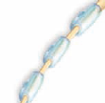

____ 22. Use the diagram above to answer the next question.
Which of the following types of nerve transmission occurs in this neuron?
a. | relatively fast and between nodes
b. | relatively slow and between nodes
c. | toward the central nervous system
d. | away from the central nervous system

____ 23. Which stage of a nerve impulse immediately follows the opening of sodium channels?
a. | repolarization
b. | depolarization
c. | resting potential
d. | refractory period

____ 24. Which of the following transmits information from an axon?
a. | a dendrite
b. | a cell body
c. | calcium ions
d. | neurotransmitter

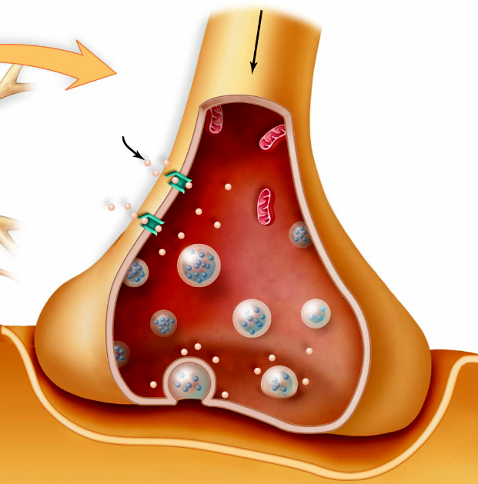

____ 25. Use the diagram above to answer the next question.
Which of the following conditions would result if norepinephrine remained bound to receptors in this region?
a. | secretions of pepsin would increase
b. | systolic blood pressure would decrease
c. | acetylcholine would be released from the axon terminal
d. | stretch receptors in alveoli would be stimulated more frequently

Chapter 12 Pre-Test A
Answer Section

MULTIPLE CHOICE

1. ANS: B PTS: 1 DIF: K REF: 12
OBJ: Nervous System LOC: C11-1 TOP: 12.1
KEY: Nervous Tissue

2. ANS: A PTS: 1 DIF: K REF: 12
OBJ: Nervous System LOC: C11-4 TOP: 12.1
KEY: Nervous Tissue

3. ANS: D PTS: 1 DIF: K REF: 12
OBJ: Nervous System LOC: C12-5 TOP: 12.4
KEY: Peripheral Nervous System

4. ANS: D PTS: 1 DIF: K REF: 12
OBJ: Nervous System LOC: C11-4 TOP: 12.1
KEY: Nervous Tissue

5. ANS: C PTS: 1 DIF: K REF: 12
OBJ: Nervous System LOC: C12-5 TOP: 12.4
KEY: Peripheral Nervous System

6. ANS: A PTS: 1 DIF: K REF: 12
OBJ: Nervous System LOC: C11-3 TOP: 12.2
KEY: Nerve Impulse Transmission

7. ANS: C PTS: 1 DIF: U REF: 12
OBJ: Nervous System LOC: C11-3 TOP: 12.3
KEY: Nerve Impulse Transmission

8. ANS: A PTS: 1 DIF: U REF: 12
OBJ: Nervous System LOC: C11-5 TOP: 12.2
KEY: Nerve Impulse Transmission

9. ANS: C PTS: 1 DIF: U REF: 12
OBJ: Nervous System LOC: C11-1 TOP: 12.1
KEY: Nervous Tissue

10. ANS: B PTS: 1 DIF: U REF: 12
OBJ: Nervous System LOC: C11-1 TOP: 12.1
KEY: Nervous Tissue

11. ANS: C PTS: 1 DIF: U REF: 12
OBJ: Nervous System LOC: C11-1 TOP: 12.1
KEY: Nervous Tissue

12. ANS: B PTS: 1 DIF: U REF: 12
OBJ: Nervous System LOC: C11-2 TOP: 12.1
KEY: Nervous Tissue

13. ANS: B PTS: 1 DIF: U REF: 12
OBJ: Nervous System LOC: C11-3 TOP: 12.2
KEY: Nerve Impulse Transmission

14. ANS: C PTS: 1 DIF: U REF: 12
OBJ: Nervous System LOC: C11-3 TOP: 12.2
KEY: Nerve Impulse Transmission

15. ANS: D PTS: 1 DIF: U REF: 12
OBJ: Nervous System LOC: C11-3 TOP: 12.2
KEY: Nerve Impulse Transmission

16. ANS: D PTS: 1 DIF: U REF: 12
OBJ: Nervous System LOC: C11-4 TOP: 12.1
KEY: Nervous Tissue

17. ANS: C PTS: 1 DIF: U REF: 12
OBJ: Nervous System LOC: C11-7 TOP: 12.2
KEY: Nerve Impulse Transmission

18. ANS: C PTS: 1 DIF: U REF: 12
OBJ: Nervous System LOC: C11-5 TOP: 12.4
KEY: Peripheral Nervous System

19. ANS: A PTS: 1 DIF: U REF: 12
OBJ: Nervous System LOC: C12-2 TOP: 12.3
KEY: Central Nervous System

20. ANS: D PTS: 1 DIF: HMP REF: 12
OBJ: Nervous System LOC: C11-3 TOP: 12.2
KEY: Nerve Impulse Transmission

21. ANS: A PTS: 1 DIF: K REF: 12
OBJ: Nervous System LOC: C12-2 TOP: 12.3
KEY: Central Nervous System

22. ANS: A PTS: 1 DIF: U REF: 12
OBJ: Nervous System LOC: C11-4 TOP: 12.1
KEY: Nervous Tissue

23. ANS: B PTS: 1 DIF: U REF: 12
OBJ: Nervous System LOC: C11-3 TOP: 12.2
KEY: Nerve Impulse Transmission

24. ANS: D PTS: 1 DIF: U REF: 12
OBJ: Nervous System LOC: C11-6 TOP: 12.2
KEY: Nerve Impulse Transmission

25. ANS: D PTS: 1 DIF: HMP REF: 12
OBJ: Nervous System LOC: C12-5 TOP: 12.4
KEY: Peripheral Nervous System

