Chapter 10 Pre-Test A

Multiple Choice
Identify the choice that best completes the statement or answers the question.

____ 1. Hemophilia affects blood clotting. Which of the following components of blood is likely not functioning properly?
a. | plasma
b. | platelets
c. | red blood cells
d. | white blood cells

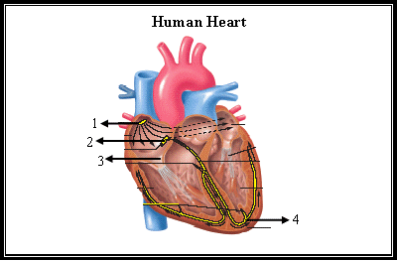

____ 2. Use the diagram above to answer the next question.
In the diagram, the SA node of the heart is labeled as
a. | 1.
b. | 2.
c. | 3.
d. | 4.

____ 3. Which of the following blood vessels will a blood cell enter after the iliac vein?
a. | aorta
b. | iliac artery
c. | anterior vena cava
d. | posterior vena cava

____ 4. In which blood vessels is blood pressure the lowest?
a. | veins
b. | arteries
c. | arterioles
d. | capillaries

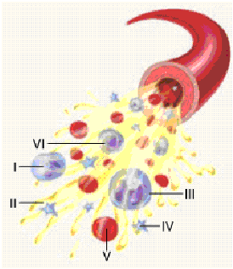

____ 5. Use the diagram above to answer the next question.
Which of the indicated blood components is a red blood cell?
a. | III
b. | IV
c. | V
d. | VI

____ 6. Use the diagram above to answer the next question.
Which of the indicated blood components is primarily responsible for the transport of oxygen?
a. | I
b. | II
c. | IV
d. | V

____ 7. Use the diagram above to answer the next question.
Which of the indicated blood components is most responsible for fighting an infection?
a. | I
b. | II
c. | III
d. | IV

____ 8. Which of the following processes is prevented by an atrioventricular valve?
a. | blood re-entering the right atrium
b. | blood re-entering the left ventricle
c. | blood re-entering the pulmonary vein
d. | blood re-entering the pulmonary artery

____ 9. In which pair of vessels is the oxygen level most similar?
a. | aorta and pulmonary vein
b. | aorta and pulmonary artery
c. | coronary vein and pulmonary vein
d. | coronary artery and pulmonary artery

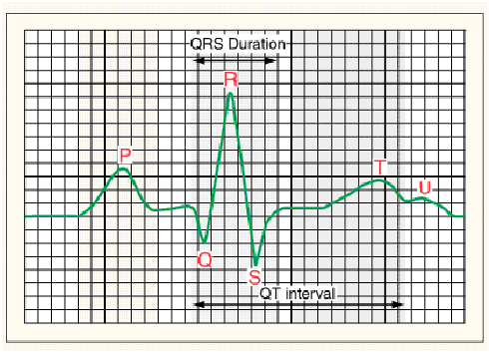

____ 10. Use the diagram above to answer the next question.
Which position indicates the point at which the SA node is activated?
a. | P
b. | Q
c. | R
d. | S

____ 11. How does the blood in the pulmonary artery compare to the blood in the aorta?
a. | Oxygen levels in both regions are low.
b. | Carbon dioxide levels in both regions are high.
c. | Oxygen levels in the aorta are lower than levels in the pulmonary artery.
d. | Oxygen levels in the aorta are higher than levels in the pulmonary artery.

____ 12. Which of the following relationships exists between blood pressure and blood velocity as blood enters a vein?
a. | blood pressure increases and blood velocity increases
b. | blood pressure increases and blood velocity decreases
c. | blood pressure decreases and blood velocity increases
d. | blood pressure decreases and blood velocity decreases

____ 13. In which of the following pairs of structures would oxygen levels be the most similar?
a. | coronary artery and renal vein
b. | coronary artery and hepatic vein
c. | pulmonary vein and umbilical vein
d. | pulmonary vein and umbilical artery

____ 14. Which of the following characteristics describes a venule but not an arteriole?
a. | thin walls
b. | thick walls
c. | connects veins and capillaries
d. | only carries deoxygenated blood

____ 15. Which of the following structures will a blood cell enter before entering a capillary bed in the kidney?
a. | a venule connected to the renal vein
b. | a venule connected to the renal artery
c. | an arteriole connected to the renal vein
d. | an arteriole connected to the renal artery

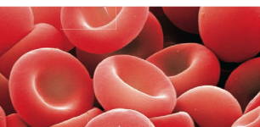

____ 16. Use the diagram above to answer the next question.
Which of the following functions is performed by the structures in the illustration above?
a. | clotting blood
b. | fighting infections
c. | transporting glucose
d. | transporting carbon dioxide

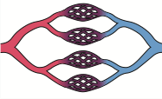

____ 17. Use the diagram above to answer the next question.
Which of the following changes occurs as blood flows through this region of blood vessels in a person’s arm?
a. | blood pressure increases and osmotic pressure increases
b. | blood pressure increases and osmotic pressure decreases
c. | blood pressure decreases and osmotic pressure increases
d. | blood pressure decreases and osmotic pressure decreases

____ 18. Which of the following substances is most responsible for creating the osmotic gradient within a capillary bed?
a. | oxygen
b. | amino acids
c. | carbon dioxide
d. | plasma proteins

____ 19. Which of the following explains how hypertension affects capillary-tissue fluid exchange?
a. | Blood pressure is low and so less fluid re-enters the capillaries.
b. | Blood pressure is high and so less fluid re-enters the capillaries.
c. | Blood pressure is low and so more fluid re-enters the capillaries.
d. | Blood pressure is high and so more fluid re-enters the capillaries.

____ 20. Which of the following pathways can a blood cell travel?
a. | aorta → iliac artery → iliac vein → anterior vena cava
b. | aorta → carotid artery → jugular vein → anterior vena cava
c. | aorta → coronary vein → coronary artery → anterior vena cava
d. | aorta → hepatic portal vein → hepatic vein → anterior vena cava

____ 21. Which of the following features do a lymph vein and the renal vein have in common?
a. | one-way valves
b. | transport blood
c. | one cell layer thick
d. | carry materials to the vena cava

____ 22. Which of the following events occurs at the same time that blood enters the right atrium?
a. | Semi-lunar valves close.
b. | Atrioventricular valves open.
c. | Blood leaves the left ventricle.
d. | Blood enters the right ventricle.

____ 23. If bacteria are detected in the blood stream, which of the following will be produced in response?
a. | lymph
b. | antigens
c. | platelets
d. | antibodies

____ 24. If atria contract normally, but ventricles do not contract normally, which of the following structures is likely malfunctioning?
a. | SA node
b. | AV node
c. | pacemaker
d. | chordae tendinae

____ 25. Which of the following descriptions refers to an artery?
a. | carries nutrients to the liver
b. | carries oxygen to the left atrium
c. | carries carbon dioxide to the lungs
d. | carries waste toward the right atrium

Chapter 10 Pre-Test A
Answer Section

MULTIPLE CHOICE

1. ANS: B PTS: 1 DIF: K REF: 10
OBJ: Circulatory System LOC: C6-1 TOP: 10.2
KEY: Blood

2. ANS: A PTS: 1 DIF: K REF: 10
OBJ: Circulatory System LOC: C4-1 TOP: 10.3
KEY: Human Heart

3. ANS: D PTS: 1 DIF: K REF: 10
OBJ: Circulatory System LOC: C5-4 TOP: 10.4
KEY: Vascular Pathways

4. ANS: A PTS: 1 DIF: K REF: 10
OBJ: Circulatory System LOC: C5-5 TOP: 10.4
KEY: Vascular Pathways

5. ANS: C PTS: 1 DIF: K REF: 10
OBJ: Circulatory System LOC: C6-1 TOP: 10.2
KEY: Blood

6. ANS: D PTS: 1 DIF: U REF: 10
OBJ: Circulatory System LOC: C6-1 TOP: 10.2
KEY: Blood

7. ANS: A PTS: 1 DIF: U REF: 10
OBJ: Circulatory System LOC: C6-1 TOP: 10.2
KEY: Blood

8. ANS: A PTS: 1 DIF: U REF: 10
OBJ: Circulatory System LOC: C3-1 TOP: 10.2
KEY: Human Heart

9. ANS: A PTS: 1 DIF: U REF: 10
OBJ: Circulatory System LOC: C3-1 TOP: 10.3
KEY: Human Heart

10. ANS: A PTS: 1 DIF: U REF: 10
OBJ: Circulatory System LOC: C4-1 TOP: 10.3
KEY: Human Heart

11. ANS: D PTS: 1 DIF: U REF: 10
OBJ: Circulatory System LOC: C3-1 TOP: 10.4
KEY: Vascular Pathways

12. ANS: C PTS: 1 DIF: U REF: 10
OBJ: Circulatory System LOC: C5-2 TOP: 10.4
KEY: Vascular Pathways

13. ANS: C PTS: 1 DIF: U REF: 10
OBJ: Circulatory System LOC: C5-7 TOP: 10.5
KEY: Fetal Circulation

14. ANS: C PTS: 1 DIF: U REF: 10
OBJ: Circulatory System LOC: C5-2 TOP: 10.1
KEY: Blood Vessels

15. ANS: D PTS: 1 DIF: U REF: 10
OBJ: Circulatory System LOC: C5-2 TOP: 10.1
KEY: Blood Vessels

16. ANS: D PTS: 1 DIF: U REF: 10
OBJ: Circulatory System LOC: C6-1 TOP: 10.2
KEY: Blood

17. ANS: C PTS: 1 DIF: U REF: 10
OBJ: Circulatory System LOC: C5-6 TOP: 10.2
KEY: Blood

18. ANS: D PTS: 1 DIF: U REF: 10
OBJ: Circulatory System LOC: C5-6 TOP: 10.2
KEY: Blood

19. ANS: B PTS: 1 DIF: HMP REF: 10
OBJ: Circulatory System LOC: C5-6 TOP: 10.2
KEY: Blood

20. ANS: B PTS: 1 DIF: U REF: 10
OBJ: Circulatory System LOC: C5-1 TOP: 10.4
KEY: Vascular Pathways

21. ANS: A PTS: 1 DIF: U REF: 10
OBJ: Circulatory System LOC: C7-2 TOP: 10.6
KEY: Lymphatic System

22. ANS: C PTS: 1 DIF: U REF: 10
OBJ: Circulatory System LOC: C3-1 TOP: 10.3
KEY: Human Heart

23. ANS: D PTS: 1 DIF: U REF: 10
OBJ: Circulatory System LOC: C6-3 TOP: 10.6
KEY: Lymphatic System

24. ANS: B PTS: 1 DIF: U REF: 10
OBJ: Circulatory System LOC: C4-1 TOP: 10.3
KEY: Human Heart

25. ANS: C PTS: 1 DIF: U REF: 10
OBJ: Circulatory System LOC: C5-4 TOP: 10.4
KEY: Vascular Pathways

